Results from pilot study into Swedish bond yields in the 1990s

Descriptive statistics scatter plot on the monthly bond yields and different explanatory variables

Figure: Scatter plot debt ratio to bond yields 2-year- (left side) and 10 year (right hand side) maturity between 1993 to 2000
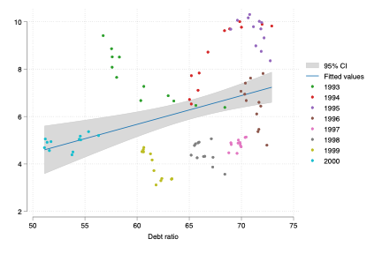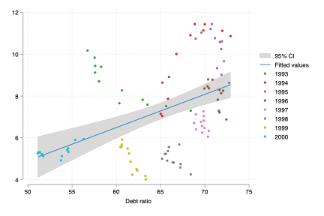

Figure: Scatter plot repo rate to bond yields 2-year- (left side) and 10 year (right hand side) maturity between 1993 to 2000
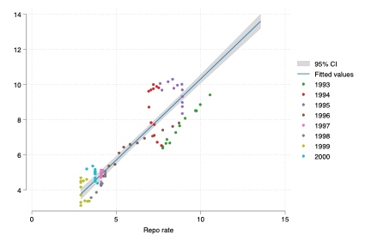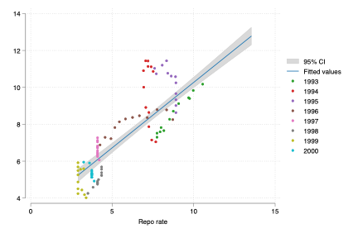
Figure: Scatter plot exchange rate to bond yields 2-year- (left side) and 10 year (right hand side) maturity between 1993 to 2000
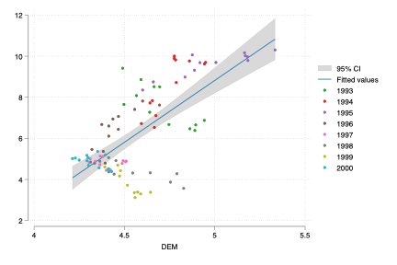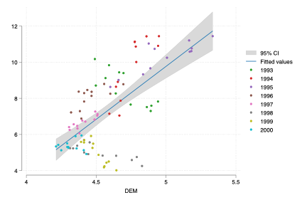

Figure: Scatter plot debt ratio, repo rate, and exchange rate to bond yield differences between germany and Sweden 1993 to 2000
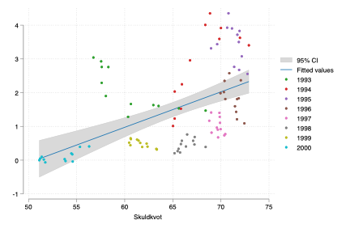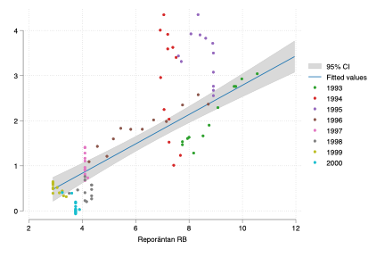
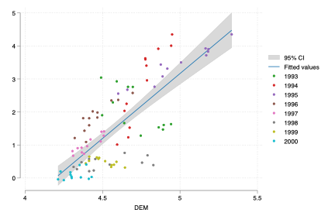

Simple OLS results

Table: OLS estimation bond yields 1993 to 2000
 | 2-year bond | 5-year bond | 7-year bond | 10-year bond | 10-year bond spread to Germany
Debt ratio | 0.021 | 0.052** | 0.057** | 0.069*** | 0.046***
 | (0.02) | (0.02) | (0.02) | (0.02) | (0.01)
Repo rate | 0.706*** | 0.632*** | 0.639*** | 0.674*** | 0.307***
 | (0.05) | (0.06) | (0.06) | (0.06) | (0.03)
DEM to SEK | 1.677** | 1.475* | 1.347* | 1.195 | 1.651***
 | (0.53) | (0.62) | (0.62) | (0.61) | (0.31)
Constant | -6.769** | -6.985** | -6.524* | -6.531** | -10.816***
 | (2.14) | (2.51) | (2.49) | (2.47) | (1.27)
$$R^{2}$$ | 0.8169 | 0.7419 | 0.7602 | 0.7661 | 0.8148
N | 96 | 96 | 96 | 96 | 96

Comment: correlation between debt ratio and most bond yields, and the bond yield spread to Germany. Especially significant and strong correlation between bond yields and the repo rate, and secondly exchange rate (DEM to SEK) to bond yield spread to Germany.

Descriptive scatter plots on the monthly first difference bond yields and different explanatory variables

Figure: Scatter plot first difference debt ratio to bond yields 2-year- (left side) and 10 year (right hand side) maturity between 1993 to 2000
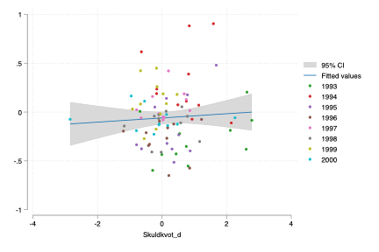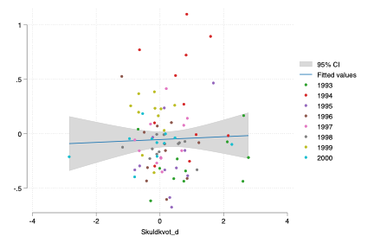

Figure: Scatter plot first difference repo rate to bond yields 2-year- (left side) and 10 year (right hand side) maturity between 1993 to 2000
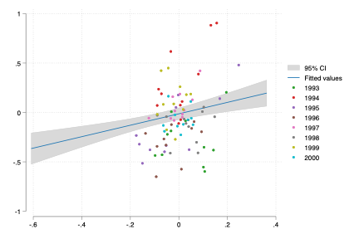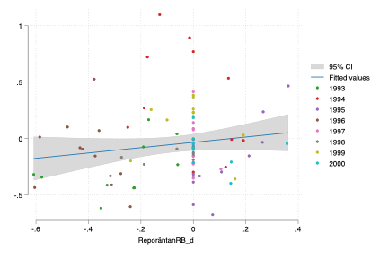

Figure: Scatter plot first difference debt exchange rate between Germany and Sweden to bond yields 2-year- (left side) and 10 year (right hand side) maturity between 1993 to 2000
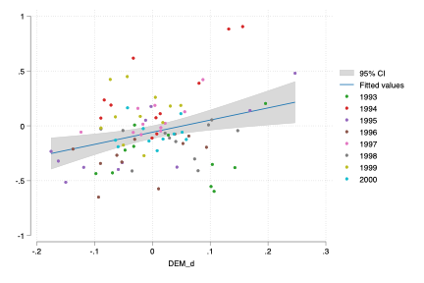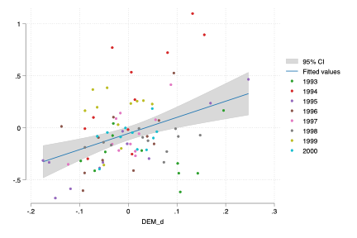

Figure: Scatter plot first difference debt ratio, repo rate, and exchange rate to bond yield differences between germany and Sweden 1993 to 2000
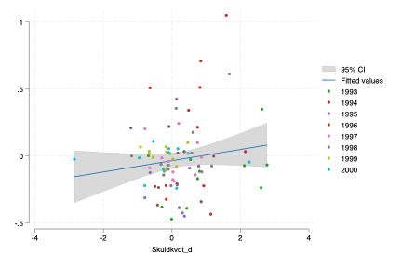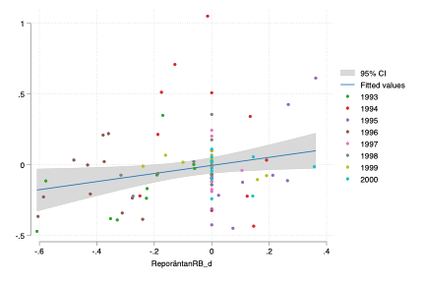
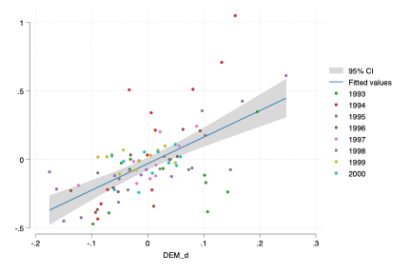

First difference OLS results
Table: First difference OLS estimation bond yields 1993 to 2000
 | 2-year bond | 5-year bond | 7-year bond | 10-year bond | 10-year bond spread to Germany
FD Debt ratio | -0.008 | -0.027 | -0.029 | -0.035 | -0.015
 | (0.03) | (0.04) | (0.04) | (0.04) | (0.03)
FD Repo rate | 0.556*** | 0.376* | 0.294 | 0.200 | 0.245*
 | (0.13) | (0.16) | (0.16) | (0.16) | (0.10)
FD DEM to SEK | 1.063** | 1.493*** | 1.545*** | 1.648*** | 1.954***
 | (0.36) | (0.43) | (0.43) | (0.43) | (0.28)
Constant | -0.016 | -0.017 | -0.027 | -0.032 | -0.009
 | (0.03) | (0.04) | (0.04) | (0.04) | (0.02)
$$R^{2}$$ | 0.2494 | 0.1802 | 0.172 | 0.1715 | 0.4115
N | 88 | 88 | 88 | 88 | 88
Comment: No clear relationship between debt ratio and any bond yield with different maturity and the bond yield spread to German bonds. However, clear first difference relation between exchange rate (DEM to SEK) and all bond yields with different maturity and the bond yield spread to German bonds.

